Cambridge Introduction to Coding Workshop

If you do not have Python installed on your laptop you should follow the instructions below. If you do then you should at least complete step 9 to confirm that it is working.
If you have a v2.x version of Python already installed, then you could complete the instructions to install v3.x as well, they will sit happily side by side (although it cause you confusion). If you just want to stick with your installed v2.x, then you can, but it will involve you making some slight adjustments to some of the code examples in the workshop.

Downloading and installing Python

- Python can be downloaded and installed from the www.python.org website.
- From the start page there is large Downloads button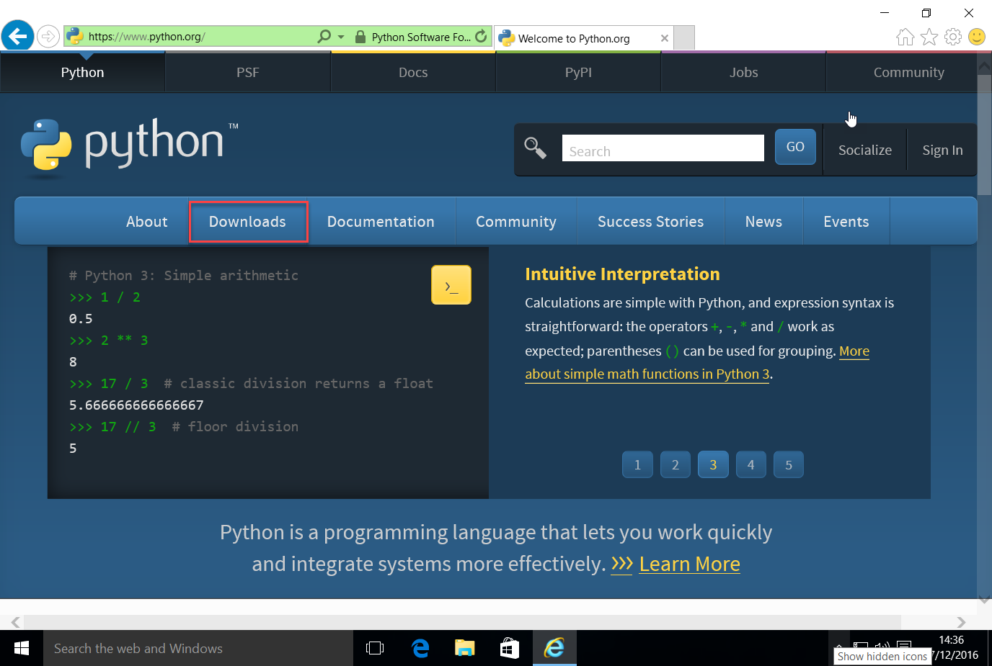
- The Downloads screen I see, know that I am on a Windows machine and offers me choices for Windows. If the Downloads screen hasn’t worked out that you are on a Mac or Linux machine, then you can specifically click the appropriate link from here. 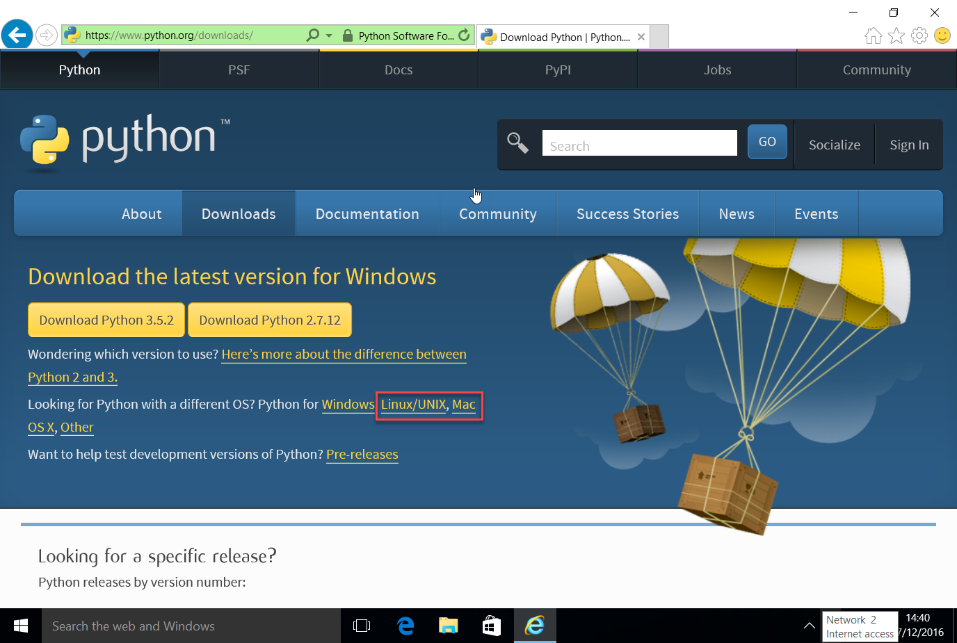
I am going to choose the Python 3.5.2 option. On other operating systems the choices may be slightly different, but there will always be a choice between v3.x and v2.x. You should choose the v3.x option.
- When you click on the download, the download will start and normally you will be given the option of saving the file and if you want to a specific location. Exactly how this looks will depend both on you operating system and on the browser you are using. On Windows using Internet Explorer, it looks like this. 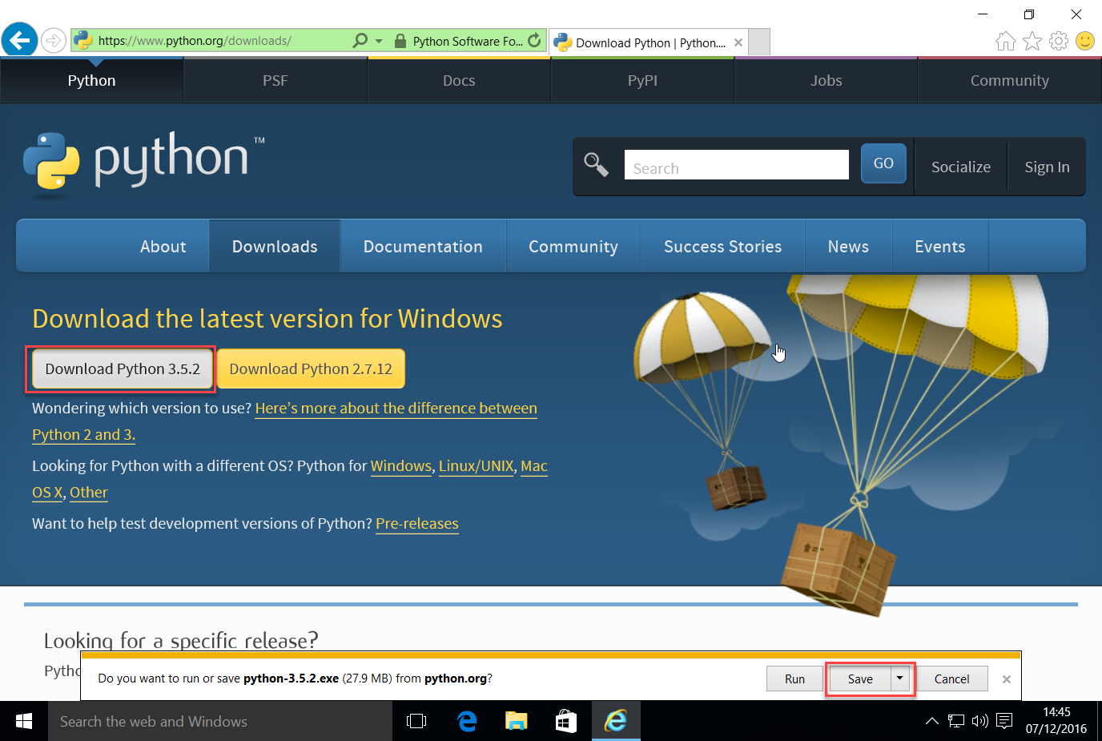
Essentially you just need to know where the downloaded file has been stored.
- Once the download is complete, you need to navigate to where the file is stored, again this will be operating system and browser specific. In Internet Explorer you get an option to open the folder where the file has been downloaded to. 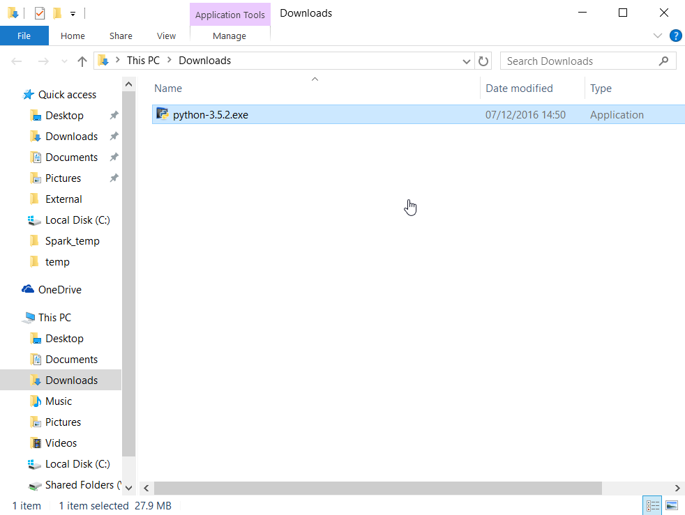
- From here you can double click the file and the installation will start. There may be slight variations in the screens shown during the installation. In Windows, there is an option for adding Python to the path. This is not checked by default, I have specifically checked it. Having done so I have clicked the Install now option. 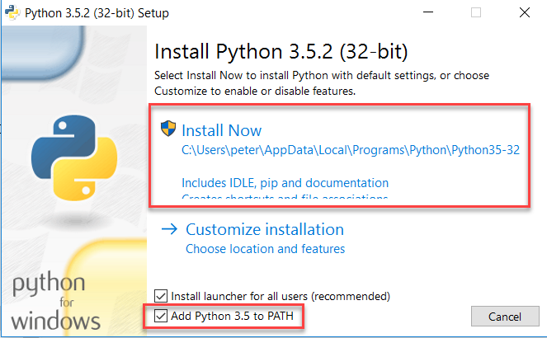
- In Windows, you will Admin rights on the machine to complete the install. If it is your laptop, then chances are you are the Administrator, in which case you will only be asked to confirm that you wish to continue. If you are not the Administrator, you will be prompted for the Adminstrators username and password which you must provide before you can proceed. 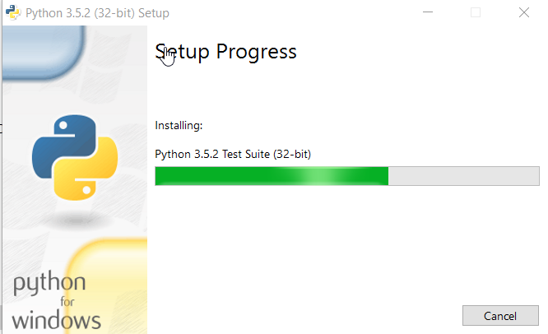
The installation can take several minutes to complete. When it does the screen changes to say that the install is complete. 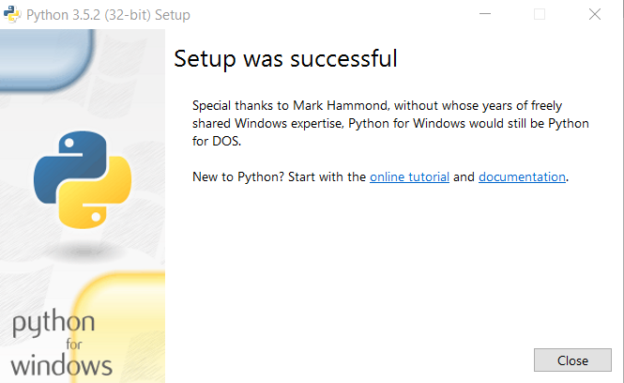
You shouls click the Done button.
- Once the installation is complete, you can try using Python. The Python program is actually called IDLE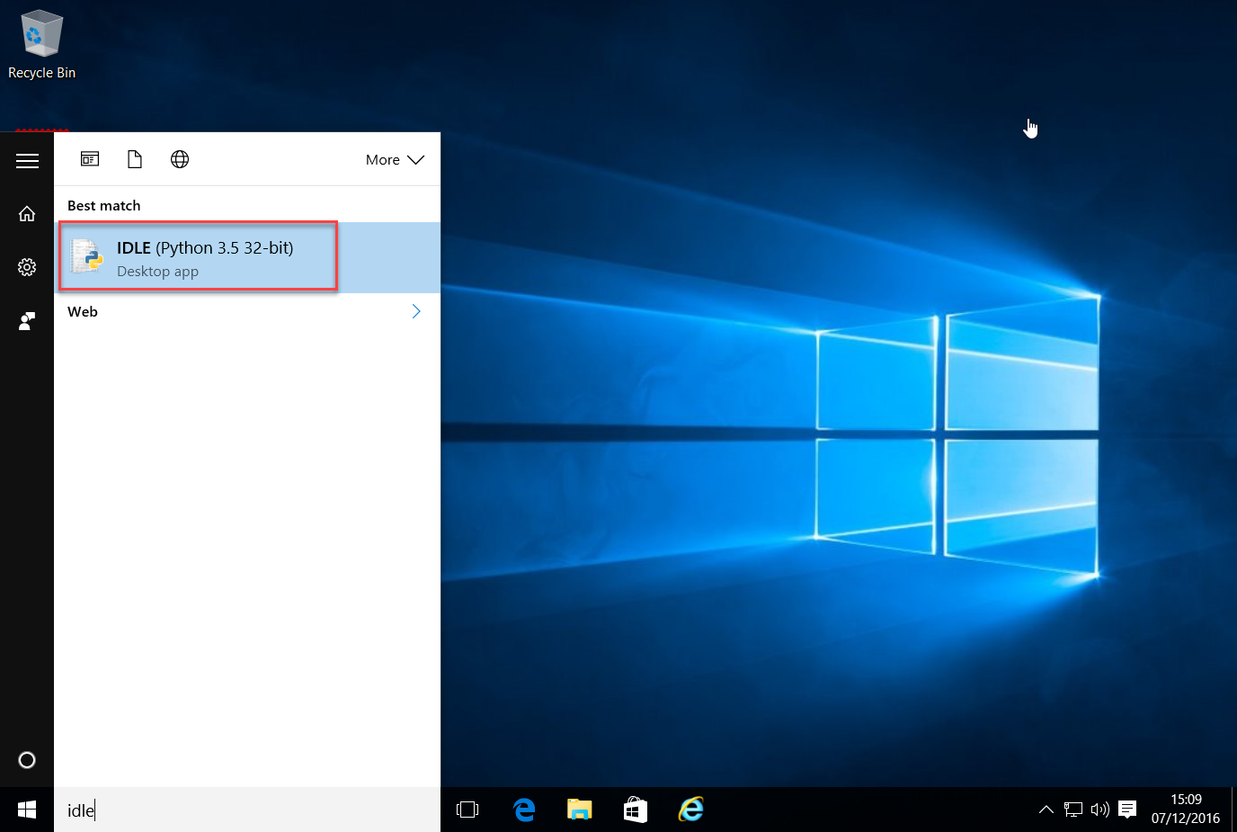
On Windows, you can get to it by searching, finding it may be different on other operating systems. The little icon is likely to be the samethough.
- When you open IDLE you should see an editing window similar to this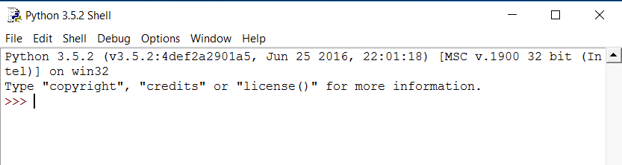
- You can type your Python code directly into it. This completes the installation and verivication of the Python install.

Downloading the course materials from Github
For this workshop we are going to use Github as a simple repository and distribution system for the course materials.
To download the materials to your laptop you should follow the instructions below
- In the browser of your choice navigate to the following URL https://github.com/pfsmyth/Cambridge You should see a screen like this. 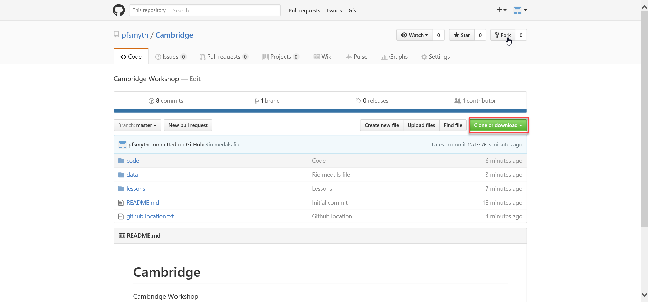
- Click the Clone or download button, and take the option to download as a zip file 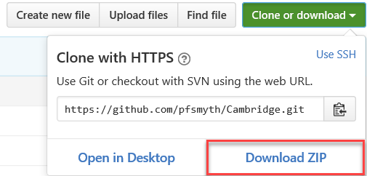
- Once the zip file has been downloaded, you can unzip it to anywhere you like on your laptop, just remember where it is.

